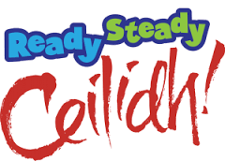
You are invited to a County Celebration
Friday 10th March 2017
At The Riley Smith Hall, Kirkgate, Tadcaster
7.00pm for 7.30pm
Come and join us and help celebrate the County’s successes during the past year
- This event is open to all members of the Senior Section, Leaders, Trefoil Members and guests invited by the organisers – membership numbers will be required
- Ticket price £5.00 per person and include supper and entertainment
- Tickets will be non-refundable from 01/03/2017
- Dress code – Non uniform
- A bar will be available – wristbands will restrict those under 18 to soft drinks
- The event will close at midnight
- The event contacts are Bev Wise, Pauline Ducat and Alison Wadsworth and Lesley Strathie who will be the points of contact for the evening along with Judith Bellamy.
- There will be full first aid provision
- RSVP by Friday 24/02/2017 to Bev Wise, 16 Auster Bank Road, Tadcaster, LS24 8AX
- RSVP with full payment, name, email address, dietary requirements and membership number – consent forms will be required by U18’s to be handed in on arrival.
- Cheques should be made payable to Girlguiding North Yorkshire South

