White Rose House Bookings Secretary
Miss D Pears, 38 Muncastergate, Malton Road, York YO31 9LA,

Tel: 01904 425732
Registered Charity No. 516246

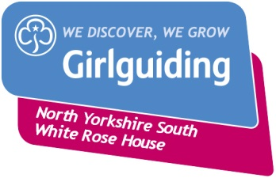

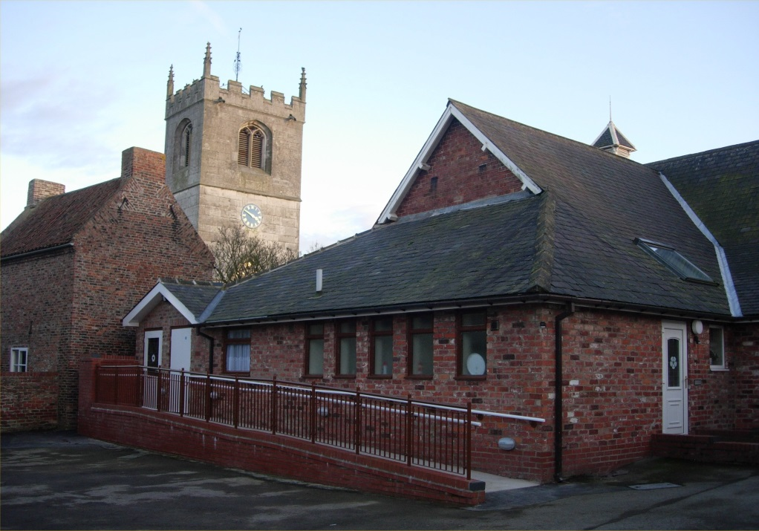

White Rose House

79 Main Street, Wheldrake, near York

YO19 6AA

Ordinance Survey Map 105 Grid Reference 682450

Booking Arrangements

The charge for hiring White Rose House is £ per night.
A non-returnable deposit of £25 is required with your booking form.
The remaining balance is payable two weeks before the first night of your stay, with an additional cheque for £25 which is required to cover any accidental damage or additional cleaning this will be refunded or the cheque destroyed if not needed.
All cheques should be made payable to The Guide Association, NYS, White Rose House.

Please check with the Booking Secretary Di Pears 01904 425732 that the dates you want are available before completing the booking form. If you would like to visit White Rose House before you book this can be arranged with the Booking Secretary.

Members of Girlguiding should complete a Residential Event Notification Form.

Conditions of Booking

- The White Rose House Committee reserves the right to refuse any application to hire out the house without stating the reason for so doing.
- The number of persons staying overnight must not exceed 30 (including adults).
- The hirer shall be liable for all damage caused to the premises and for the payment or replacement of all breakages.
- The premises must be left clean and tidy.
- Care must be taken to ensure that no noise or nuisance to neighbours is created.
- Guide Association Insurance ONLY covers members of Girlguiding. If you are a non Guide Association organisation YOU ARE NOT COVERED BY us and must arrange your own insurance cover for everything involved during your stay.The Committee accepts no liability for damage to or loss of possessions.
- In the event of a cancellation deposits are non-refundable. Cancellations six weeks prior to arrival will incur half the total cost of the booking, those within 6 weeks of arrival will be charged at the full amount. Where possible we would make every effort to re-let the property, if this is successful the above would not apply
The hirer is therefore strongly advised to take out Holiday Cancellation Insurance to cover this eventuality.
Bookings will only be confirmed on receipt of the completed application form and deposit. This should be within 2 weeks of receiving the form

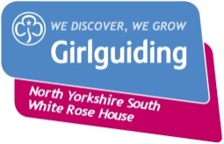 White Rose House

White Rose House is set in the peaceful village of Wheldrake, 8 miles from historic York. Originally the village primary school, the House was bought by Girlguiding North Yorkshire South and converted into an excellent multi-purpose facility for use by members of Girlguiding UK and other youth and community organisations. Mixed groups wishing to hire for overnight stays should be aware of the limitations of the accommodation from a safeguarding perspective.

Facilities

The House is suitable for both day and residential use and comprises:

- Large hall
- Small hall
- Washroom with toilets, washbasins and two showers
- Drying room for boots and wet weather clothing
- Bedroom suitable for use by disabled person and their carer
- 30 Camp Beds with cell foam pads, and one pillow
- Fully-equipped kitchen
- Gas central heating (cost included in rent)
- Tarmac car park/play space to the rear of the building (with gates)

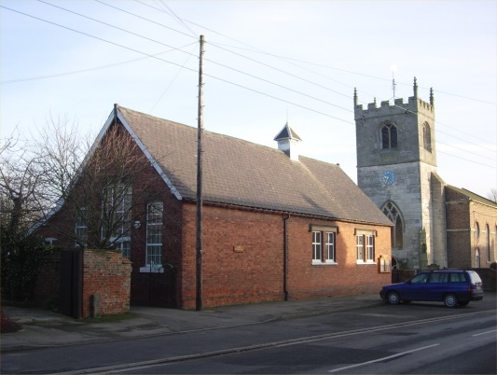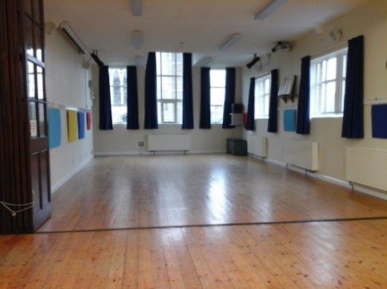

White Rose House Large Hall

Disabled guests & young children

The entire building is fully wheelchair accessible and is also suitable for the visually impaired. The bedroom designed for use by a disabled guest and their carer is a recent addition to the facilities at White Rose House and features an adjustable bed, a bed for the carer and a fully equipped ensuite wet room.

White Rose House is also particularly well suited for use by young children, and it has been fitted with low surface temperature radiators as well as lower level toilets and washbasins.

Capacity

White Rose House can accommodate a maximum of 100 people for daytime meetings and can sleep up to 30 people (including adults), on camp beds.

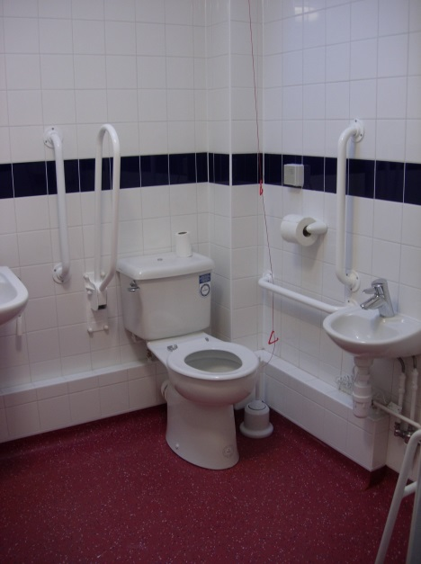

Accessible Wet Room

Medical Matters

Doctors – Elvington Medical Practice have a surgery on Main Street, Wheldrake. Telephone 01904 608224. Limited opening times,check for up to date hours.

Hospital – York District Hospital, Wigginton Road, York, YO31 8HE. Telephone 01904 631313. There is an A&E Department at this hospital.

Churches

Church of England – St Helen’s Church, Wheldrake. Services as indicated on the church noticeboard.

Roman Catholic – Thicket Priory, Carmelite Monastery, on the road to Thorganby. Mass 9am Sundays.

Methodist – Thorganby Village, telephone contact 01904 702223

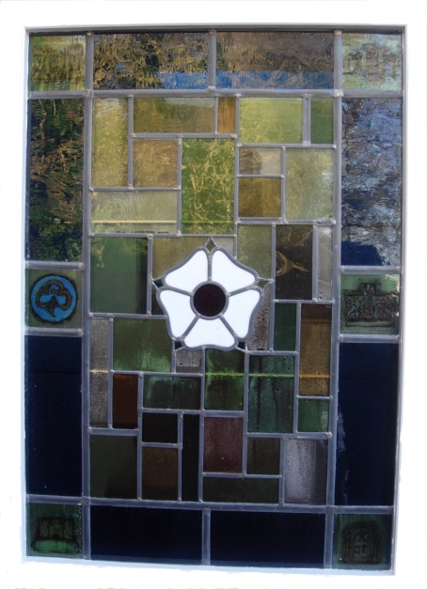

Our stained glass window

Local Information

Shops & Post Office

Butcher – the butcher’s van visits Wheldrake on Tuesday and Fridays.
Butcher Peter Healey Tel: 01757 248515

Costcutters – situated on Main Street, Wheldrake and stocks the basic essentials. Open Monday to Saturday 7am-9pm, Sunday 8am-9pm.

Tesco, Asda & Sainsbury’s – located in and around York (there is also a Tesco store in Selby). They will all deliver to White Rose House if the order is made online. (79 Main Street , Wheldrake, YO19 6AA)

Post Office – situated in Costcutters. Open Monday to Friday 9am-5.30pm, Saturday 9am-12.30pm.

Transport

Buses – there is a regular public bus service connecting Wheldrake to York city centre from Monday to Saturday operated by Transdev bus No. 36 and East Riding Bus No 18.

Park & Ride – a park and ride service operated by First York runs 7 days a week from the McArthur Glen Designer Outlet at Fulford, approximately 10 minutes by car from Wheldrake.

Thornes Independent Ltd – private coach hire, with a variety of sizes of coaches available. Telephone 01757 630777.

House Information

Arriving and Departing
We have a secure key box fitted next to the side door of the building, the code to access this will be sent to you on receipt of the balance of your payment, this should be with the booking secretary two weeks before your arrival.

On departure please complete the checklist and leave in the small hall. Please return the key to the key box.

Things to Bring
Although there are camp beds with cell foam pads, and pillow for up to 30 people, visitors will need to bring their own sleeping bags, pillow cases and blanket.

The kitchen has a gas cooker, a fridge freezer and plenty of crockery. Visitors need to provide their own tea towels, dishcloths, towels, washing up liquid, toilet rolls, and bin liners. All other cleaning materials are supplied.

First Aid
Group Leaders are expected to bring their own First Aid Kit. For emergency use there is a First Aid Box in the kitchen.

Fire Precautions
In the event of a fire, the fire exit is via the main door of the building OR the side door near the washroom. The fire alarm is on the wall in the entrance hall with full instructions on the wall nearby. There is a fire blanket in the kitchen near the cooker. A fire practice should be held early in your stay. Please record this in the book provided.

Television
We have a DVD player with large screen for your use but NO TV Licence

Telephone
There is a telephone in the small hall. The telephone number is
01904 448880. Please pay for any calls made. Please note that some mobile phone reception in Wheldrake is very poor.

Souvenirs
A selection of White Rose House souvenirs are available for sale.

Correspondence
Please do not send any correspondence to White Rose House except to those staying.

Things to do

York (8 miles)
The ancient city of York is just 8 miles from White Rose House, and is full of interesting things to see and do, including historic sites such as York Minster, Clifford’s Tower and The Shambles and museums such as the National Railway Museum, Castle Museum and Jorvik Centre. York also plays host to a number of special events and festivals throughout the year including the annual Viking Festival.

To find out more about York, its wealth of visitor attractions and special events as well as practical information including bus timetables, visit www.thisisyork.co.uk.

Wheldrake Woods
The woods are managed by the Forestry Commission and are home to a wide variety of wildlife, including fallow deer, bats and butterflies. For more information see www.forestry.gov.uk

Wheldrake Ings
Wheldrake Ings consists of the banks and water meadows of the Lower Derwent and is an important nature reserve – particularly for winter migrant birds and wild flowers. See www.yorkshire-wildlife-trust.org.uk for further information.

Play Area
There is a children’s play area on Broad Highway, Wheldrake (near the school).

A folder in the small hall at White Rose House gives more information about places of interest in the local area.

Location Map

Courtesy of Multimap

