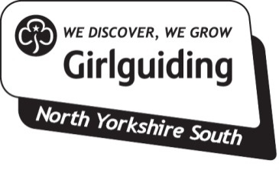
Safe Space Level 3 Training
Event information & application

What? | Safe Space Training  Aimed at Unit Leaders
When? | 4th March 2020  Arriving from 6.00pm for 6.30pm start, finishing at approx. 9.30pm
Where? | North East England Region office, York  Please come in Uniform
Who for? | Unit Leaders
How much?  Closing date: | Free  26th February 2020

Spaces are limited and are on a first come basis.
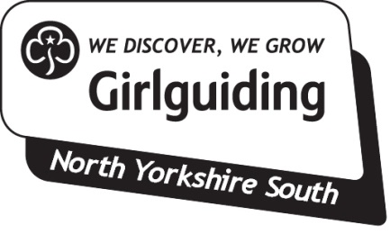 | Booking Terms and Conditions for Safe Space Training

A confirmation of booking will be issued by Girlguiding North Yorkshire South.

Cancellation by Participant
Cancellation must be made via e-mail
Email: nys@girlguidingnortheast.org.uk

Cancellation by Girlguiding North Yorkshire South
Girlguiding North Yorkshire South reserves the right to modify or cancel the event if unforeseen circumstances arise. In the event of cancellation a full refund of the event fee paid to Girlguiding North Yorkshire South will be made to participants.

Safe Space Level 3 Training
Event information & application

Full name

Membership no.

Contact telephone

Email address*

Unit name

Division

Please return this form by
26th February 2020 to:

Email:
nys@girlguidingnortheast.org.uk

Important, please read:
By booking a place on this event you are accepting the terms and conditions provided with this booking form

**If you do NOT want us to share your email address with other participants of this particular event, for example for transport sharing, please tick this box □
We will use the email above to communicate any changes to the booking and confirm booking

