Photography Competition 2021
‘Tis the Season for…….!

The Creative Activities Team is running another photographic competition for all members of Scouting and Guiding within North Yorkshire. This year it will be in four sections following the seasons of the year with the titles of ‘tis the season of ….’ So we will have;

- ‘tis the season of Winter from January to March inclusive
- ‘tis the season of Spring from April to June inclusive
- ‘tis the season of Summer from July to September inclusive and
- ‘tis the season of Autumn from October to December inclusive

So break out the cameras and phones and get started with ‘Winter.’ Feel free to interpret the theme in any way you like: be it activities relative to the season, the changing urban or rural landscape, wildlife etc.

Entries will be judged in the various sections from Rainbows and Beavers through to Leaders and Active Support/Trefoil Guild.

As a change from previous years we will be happy to receive entries at the end of each season (with the first entries at the end of March), we will publish the best from each season on the relevant County website and then hold them over for eventual winners at the end of the year. Each person may enter a maximum of five photographs per season, which must have been taken by the entrant, to the competition. Submissions must be in digital jpg format, entries taken on camera phones will be accepted.

All photographs must be submitted with the name of the photographer, section (Beaver, Brownie etc.), Scout or Guide group, District plus Guide County details, an email and postal contact (to receive a certificate) and confirmation that the photograph(s) is all the entrant’s own work. The entries will be judged in the appropriate section, all judging will be anonymous and the decisions of the judges will be final.

Photographs must be submitted to the following email address only: creative@nys.org.uk

Any photographs submitted to the competition may be used by the Scout or Guide Counties for any Scouting or Guiding purposes. All other rights are retained by the photographer.

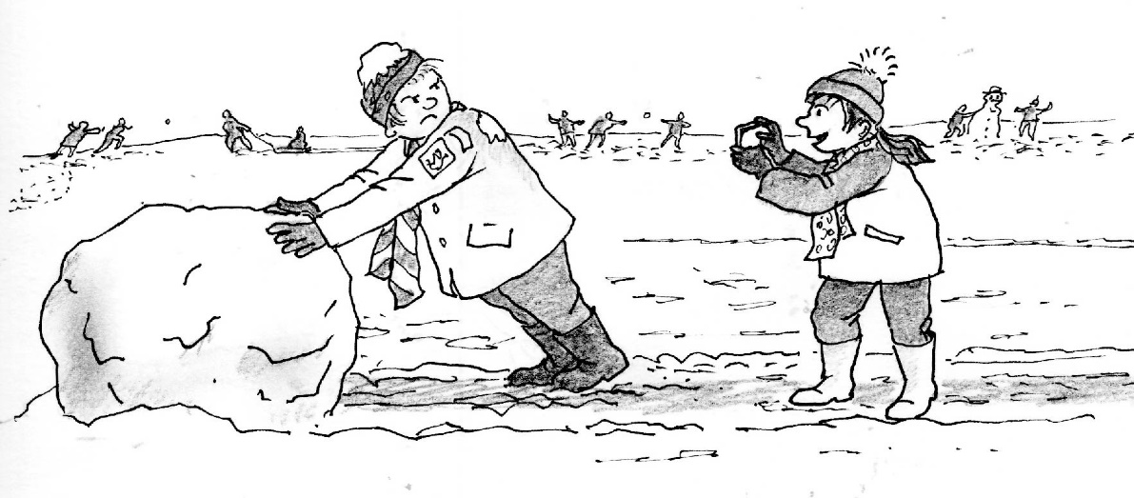
Further information or for any queries please contact;

John A Ives
ACC, Creative Activities
North Yorkshire Scouts

creative@nys.org.uk

