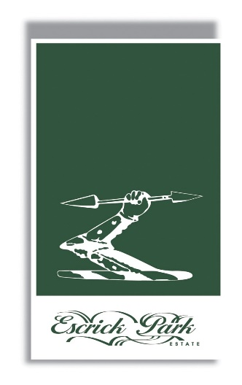
Girlguiding North Yorkshire South
Saturday 21 October 2023
Escrick Park Sponsored Walk

Come and join in a sponsored walk around the lovely Escrick Park Estate.
The sponsor money you raise will be shared between White Rose House Wheldrake and your own unit. Sponsor form attached.
There are 2 routes open to all sections:
- Route 1 – 2 miles
- Route 2 – 5 miles
Once we know how many units are taking part you will be given a start time between 10am and 12noon. Risk Assessments for the event will be shared shortly.
Please let us know if you are taking part by providing the information below
to countyadministrator@girlguidingnys.org.uk by 30 September 2023.
Information Required
Unit Name: ___________________________________________________
Unit leader:___________________________________________________
Email address: ________________________________________________
Telephone number: _____________________________________________
Numbers
Number of: | Rainbows | Brownies | Guides | Rangers | Adult Volunteers

Any questions please email countycommissioner@girlguidingnys.or.uk

Please gather as many sponsors as you can. Do this just from your family and friends,
do not ask strangers or go to anyone’s house you don’t know.

Gift Aid gives us an extra 25p for every £1 you donate. Gift Aid is an income tax relief designed to benefit charities. If you’re a UK taxpayer, Gift Aid increases the value of your charity donations by 25% because we can reclaim the basic rate of tax on your gift at no extra cost to you. All you need to do is tick the box.
Walkers Name: …………………………………………………………………...

Name | Address | Amount per mile | Total | Gift Aid? | Paid

 | Total Raised | £

