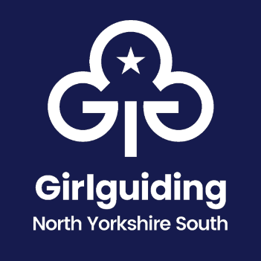
Savvy Saturday 7 October 2023

Booking Form (2 pages)

Your name…………………………………………………………………………………………………………………………………..

Membership Number…………………………………………………………………………………………………………..

Unit Name/Role……………………………………………………………………………………………………………………….

Email Address…………………………………………………………………………………………………………………………….

Details of special needs the trainers should take into account e.g. mobility, dyslexia, allergies etc.

…………………………………………………………………………………………………………………………………………………………….

…………………………………………………………………………………………………………………………………………………………….

……………………………………………………………………………………………………………………………………………………………
Please select which payment method you will use:
BACS/Cheque (delete as appropriate)
*There is a £5 charge for this event (a legitimate unit cost) payable in advance of the session either via BACS (Sort code 30-99-99, account number 00371610 ref SAVVY) or cheque (payable to ‘Girlguiding North Yorkshire South’), which can be posted to Elizabeth Greenaway, Girlguiding North East England, 7 Alpha Court, Monks Cross Drive, Huntington, York, YO32 9WN

Session Preference
Please select the sessions you would like to attend and rank them from 1 (most preferred) to 6. We will endeavour to try and accommodate as many of your higher preferences as possible and will notify you of the sessions you’ve been allocated to one week prior to the event.

Session Description | Ranking (1 – 6 preference)
Programme Solutions
Admin Hacks
Turning parents into Volunteers
Recognising our Volunteers
Your wellbeing matters
Sports coordinators
Activity exchange
Treasurer’s tips
Using our branding
Its more than RENS
Able not Disabled
Adventure for units
Yeah for Young Leaders!

Please send this completed form to Elizabeth on countyadministrator@girlguidingnys.org.uk

